**Wap to create a file name student_records.txt and insert the content to it.**

**Contents**

**1 Ram 30 , 2 Shyam 29, 3 Sita 25**

**Output:**

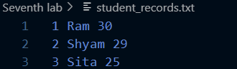

**Wap to read contents and display in console from file student_records.txt.**

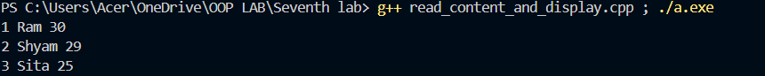**Output :**

**Wap to modify the age of Shyam from 29 to 22 that is available in the file student_records.txt**

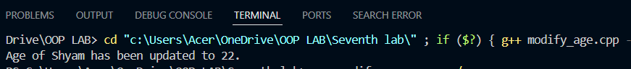**Output :**

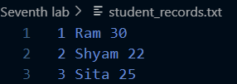

**Wap to delete record of Sita from the file student_records.txt and display the remaining rows.**

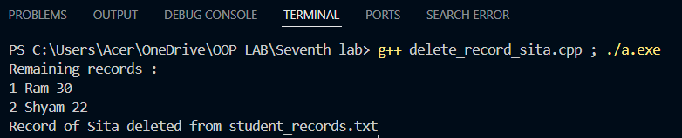**Output:**

**Wap to append contents in the filename demo.txt.**

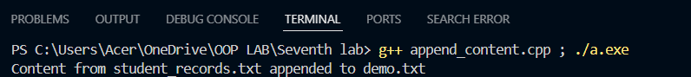**Output :**



**Wap to read contents from filenamed demo.txt and print number of character available in the file.**

**Output:**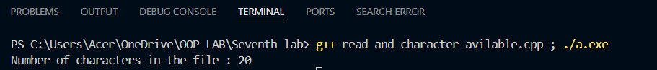

**Wap to read content from the file name demo.txt and print number of words and number of lines available in the file.**

**Output :**

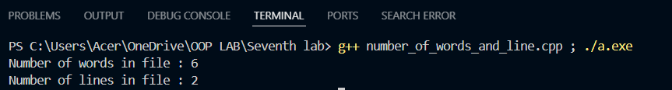

**Wap to create files named file1.txt and file2.txt with same text in those files. Also merge the contents of those two files into the file name file3.txt**

**Output :**

